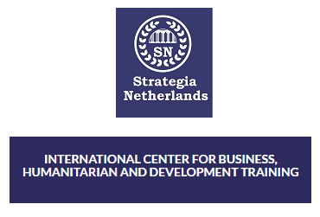

MODULE THREE ASSIGNMENT

CERTIFICATE IN WASH

Submitted by:
Elvis Timothy Ogweno

Date of submission: 30th November 2019

MODULE THREE QUESTIONS
- Describe an ideal way of ensuring that hand washing is a culture and not a belief
An ideal way of ensuring hand washing is an inculcated culture among communities is by addressing emotive drivers of handwashing within existing social norms. One of the ways is by inducing behavioral change by indulging family members, providing handwashing facilities and illustrating to people some of the health threats posed by dirty hands (Parveen et al., 2018). The concept of how germs and disease causing pathogens get into our hands, get ingested causing diseases, should be properly articulated and linked to poor hygiene habits. Facts on hand washing can be stressed during sensitization through role playing, use of illustrations, story narration or use of past experiences for the community to distinguish facts from beliefs. Sensitization ought to factor the following:
How germs get onto our hands: Human or animals waste contain germs like Salmonella, E. coli, and norovirus which causes diarrhea and respiratory infections. These microbes possibly get to our hands after visiting the toilet, changing a diaper, handling uncooked meats etc. According to Franks et al., (1998) single gram of human waste can contain one trillion germs. Germs can also get onto hands by touching contaminated objects (Adlem, n.d.)
Ways in which the germs get spread
- We touch our eyes, nose, and mouth without even realizing and germs at that point can get into our bodies and make us sick.
- When consuming food or drinks prepared by unwashed hands.
- Germs from unwashed hands can be transferred to other objects, like handrails, table tops, or toys, and then transferred to another person’s hands.
What to do to keep hands free of germs
- Wash hands regularly with recommended detergent and using clean running water especially after visiting the toilet, before eating, after changing diaper and after eating. Additionally, foods eaten raw such as fruits should first be washed thoroughly.
- Air dry your hands to prevent recontamination
The process of washing hands should also be adhered to so that the process by itself is not marred with any controversy or so that by itself it doesn’t exacerbate a situation it is meant to abate.
- In your own view, what should be done to communities who use one source of water for various purposes i.e. drinking, bathing, washing clothes and utensils, swimming and livestock using
To remedy the culture of people using same water source for drinking, bathing, washing clothes and utensils, swimming and livestock use, leaders and role models in the society should take an initiative of educating community members how to manage water and uphold their sanitation activities to acceptable international levels. Besides sensitization, the communities need also be educated on health hazards resulting from continued perpetuation of such ethos.
- There are communities who do not belief in fathers sharing sanitation facilities with their daughters, how would you handle a situation like this if you are a volunteer promoting digging of latrines in such a community
A practical approach would be to carry out an awareness campaign on the importance of using toilets so as to try make them change their mind-sets. Where there is redundancy to change, the design of the toilets would be customized to accommodate people’s customs. If sharing for instance is a taboo, the designed latrine would be divided into at least two chambers so that children use one room and the parents use the other room. This is because according to (Nawab et al., (2006), “people look at things through their cultural lenses”. There is need However for maximum sensitization to discard the obnoxious custom. The government would also be approached to help subsidize in building of toilets and latrines.

- Explain how you will come up with a system for disposal of sanitary towels in rural and remote villages where it is even a taboo to use sanitary towels
Disposal systems of sanitary towels can’t be comprehended and designed out in isolation without consideration of the end user’s social, religious or cultural customs on menstruation, product used and the existing sanitation systems (Elledge et al., 2018). In urban and rural settings, the design of sanitation systems needs to be responsive to the following: have proper disposal systems of menstrual waste, provides appropriate discretion, high hygiene standards and doesn’t contaminate the environment.
In rural areas, poor management of menstrual hygiene is an attribute of patriarchal frameworks where menstruation is a taboo topic often kept outside the purview of polite discussions (Pathak & Pradhan, 2016). A rural woman encounter myriads of challenges in trying to access clean absorbents, clean water for washing or even privacy. With this in mind, and the absence of modernized menstrual hygiene facilities in rural areas, the following options can be thought to be appropriate and sustainable systems of disposing sanitary towels in rural areas:

Deep burial: absorbent material can be disposed in a pit and covered with soil. The pit should be 5-7 metres away from water source. The size of the pit is determined by the number of users. Where pit latrine is available, used sanitary towels can be wrapped and disposed in the pit. Always cover the pit to prevent odours and insect vectors (Murye & Mamba, 2017).
Composting: degradable menstrual absorbent is mixed with other bio-degradable materials to make compost that can be used later as fertilizer. Composting pit ought to be covered well with soil to avoid bad odors and rodents destruction (DaSilva, 2018).
Pit burning: This is an option in place of incinerators. Burning is done in a 1m deep pit and wood or kerosene added to aid complete burning (Elledge et al., 2018).

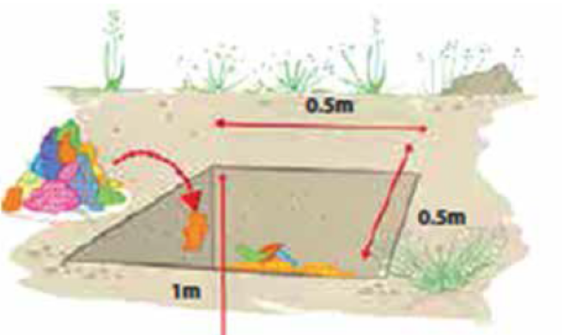  1. Deep burial | 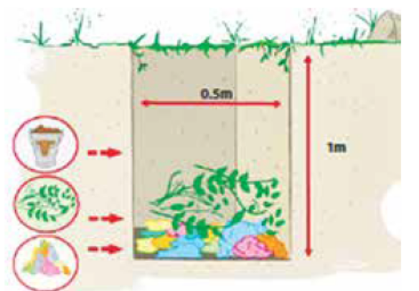  2. Composting
Emphasis should however be directed on the use of reusable sanitary or cloth pads as the most sustainable method for rural communities. Whereas there’s need for girls and women to be sensitized on health and environmental impacts caused by improper disposal of used menstrual products, men’s ignorance and misconceptions surrounding menstrual health needs urgent address (Kaur, Kaur, & Kaur, 2018). | 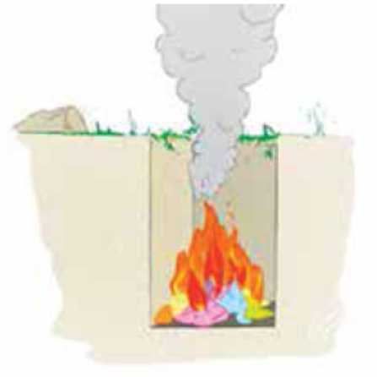  3. Pit burning  Photos adopted from the technical guide, safe disposal and incinerators

- Explain the main objectives of an efficient operation and maintenance of water supply system
The general objective of operation and maintenance of water supply system is to guarantee adequate, reliable and sustainable supply of safe water and sanitation facilities to the end users. Operation would entail activities relating to monitoring system state, running of the system and enforcing policies and procedures. This is meant at ensuring routine and timely running of the system. Maintenance on the other hand is purposed at keeping the infrastructure in good condition by scheduling activities such as condition assessment, servicing, repair and replacement of system components. These maintenance technical activities are needed to keep the system working and can either be planned or reactive (Van Zyl, 2014).
- In remote and rural villages, how would you design and make sure that the inhabitants have an efficient operation and maintenance of water supply system
The following will be my guiding principles when designing an O&M of water supply for rural areas;
- Sustainability of a facility is highly dependent on its ease of operation and maintenance aspect. Complexity of the designed operation and maintenance procedures would therefore be such that it can be handled by the available local technicians using technical options available in the locality.
- The design will provide for institutional and legal criteria such as training capacity and follow-up support,
- Involvement of stakeholders will also be an integral component in my O&M design.
- The design will have monitoring capacity and budget allocations
- It’ll incorporate communities’ perception of benefits, culture, habits, beliefs and their ability to sustainably manage and maintain O&M systems would be part of the design (Brikké, 2000).
Regarding efficiency in operation and maintenance of water supply system in the community, the following measures would be put in place:
- Adoption of community ownership and maintenance approach
- Making end-users directly responsible for the operation and maintenance of the installed facilities
- Availing at the onset of planning contractor’s and engineers ‘owner’s manual’ which would be followed during operation and maintenance. The manual will spell out schedule and procedures for maintenance and include methods of carrying out tasks.
- Informing community households and members of the system put in place for a proper operation.
- On-hands Training of Private operators or local engineering companies, end-users, their organizations (CBO’s, NGOs) overseeing operations and maintenance to ensure correct operation and maintenance of the system.
- What are the duties of the municipal/county government in ensuring an efficient operation and maintenance of water supply system
Duties of the municipal/county government in O&M of water supply may include:
- Promote awareness of national policies and provide support to community water-user committees.
- Regularly undertake water tests for microbial contamination
- In case of contamination, the municipal/county government locates and seal the source of contamination and disinfect contaminated water.
- They also check water level and test source yields
- Where the cost of water supply is high, it provides subsidy to make it affordable to the community
- Community management of operation and maintenance of water supply system has been termed as efficient for rural projects. Do you agree with the statement? Explain your answer
Indeed I’m in concurrence with the statement. This is because community management is an integral sustainability element. The need to involve community members of both genders is crucial in generating long standing community commitment to improved services, ownership and sustainability of the services. It also gives the community an opportunity on the choice of technology to be used and make them aware of the financial, managerial and technical implications of their choices, including the future O&M tasks associated with the technology (Brikké, Bredero, Supply, & Network, 2003).
Overlooking or insufficient involvement of community members causes acceptability resistance thus jeopardizing provision of improved services and sustainability of the project.
- Explain the difference between an ecosan latrine and a standard pit latrine.
Standard pit latrine | Ecosan toilet
Both urine and faeces get mixed in the pit | Urine and faeces do not mix. There’s a separating system
Once the latrine is full, a new pit has to be dug | They can be used for a very long time because decomposed waste is emptied and used as manure since it’s considered a resource
There’s possibility of contamination since fecal microorganisms have the ability to migrate from the pit through the soil. Similarly, if the water table is close to the surface, contamination of ground water is apparent | With Ecosan, there’s low contamination of the environment caused by human excretion and faecal-orally transmitted diseases are prevented
Widely acceptable across many cultures since squatting is normal to many people | Cultural taboos against handling of excreta makes it less popular. Some people maybe be even unwilling to use crops and foods grown from excrete manure.
Construction measurements are less compared to ecosan hence least space is required | The design of an ecosan system require more space

- What are the potential risks posed to the environment in using dry pit latrines?
- Pit latrines contaminates ground water where water table is high (Banks et al., 2002; Kiptum & Ndambuki, 2012;Graham & Polizzotto, 2013; Dzwairo, Hoko, Love, & Guzha, 2006).
- There’s migration of fecal microorganisms from pit through the soil causing contamination of both soil and well or borehole water (Banerjee, 2011)
- Foul oduor can be a favorable breeding ground of flies and mosquitoes. These insect vectors are potentially dangerous if a safe distance between the toilet and the kitchen is not observed (Sarwar, 2015)
- List the materials you would need to make a simple device for hand washing
- A Jerry can, tin can, wooden bowl, pottery or any other similar container
- Liquid soap container
- A string
- Three round poles, approximately 1 to 3 inch in size
- A pedal stick
- Explain how you will ensure that a latrine is user friendly to those who are disabled?
- Making wider doorways to allow easy roll-in roll-out of wheelchair users
- Constructing grab rails to provide support, stability and balance for users when shifting to and from the toilet.
- Hand washing facility and soap detergents would be at a comfortable level to the physically challenged.
- Spacious and obstacle free toilet will ensure easy maneuvering even with a wheelchair
- Proper signage to ensure convenient locating of the toilet by the special needs persons.

REFERENCES
Banerjee, G. (2011). Underground pollution travel from leach pits of on-site sanitation facilities: a case study. Clean Technologies and Environmental Policy, 13(3), 489–497.
Banks, D., Karnachuk, O. V., Parnachev, V. P., Holden, W., & Frengstad, B. (2002). Groundwater contamination from rural pit latrines: examples from Siberia and Kosova. Water and Environment Journal, 16(2), 147–152.
Brikké, F. (2000). Operation and Maintenance of rural water supply and sanitation systems. IRC, Delft, Netherlands, Prepared for WHO.
Brikké, F., Bredero, M., Supply, W., & Network, M. (2003). Linking technology choice with operation and maintenance in the context of community water supply and sanitation: A reference document for planners and project staff.
DaSilva, A. (2018). Terra Femme: A Social Entrepreneurship Investigation into Composting Menstrual Waste. 2018 NCUR.
Dzwairo, B., Hoko, Z., Love, D., & Guzha, E. (2006). Assessment of the impacts of pit latrines on groundwater quality in rural areas: a case study from Marondera district, Zimbabwe. Physics and Chemistry of the Earth, Parts A/B/C, 31(15–16), 779–788.
Elledge, M. F., Muralidharan, A., Parker, A., Ravndal, K. T., Siddiqui, M., Toolaram, A. P., & Woodward, K. P. (2018a). Menstrual hygiene management and waste disposal in low and middle income countries—a review of the literature. International Journal of Environmental Research and Public Health, 15(11), 2562.
Elledge, M. F., Muralidharan, A., Parker, A., Ravndal, K. T., Siddiqui, M., Toolaram, A. P., & Woodward, K. P. (2018b). Menstrual hygiene management and waste disposal in low and middle income countries—a review of the literature. International Journal of Environmental Research and Public Health, 15(11), 2562.
Franks, A. H., Harmsen, H. J., Raangs, G. C., Jansen, G. J., Schut, F., & Welling, G. W. (1998). Variations of bacterial populations in human feces measured by fluorescent in situ hybridization with group-specific 16S rRNA-targeted oligonucleotide probes. Appl. Environ. Microbiol., 64(9), 3336–3345.
Graham, J. P., & Polizzotto, M. L. (2013). Pit latrines and their impacts on groundwater quality: a systematic review. Environmental Health Perspectives, 121(5), 521–530.
Kaur, R., Kaur, K., & Kaur, R. (2018). Menstrual hygiene, management, and waste disposal: Practices and challenges faced by girls/women of developing countries. Journal of Environmental and Public Health, 2018.
Kiptum, C. K., & Ndambuki, J. M. (2012). Well water contamination by pit latrines: a case study of Langas. International Journal of Water Resources and Environmental Engineering, 4(2), 35–43.
Murye, A. F., & Revelation Mamba, S. (2017). Practices of Managing Menstrual Hygiene by Girls in Public Boarding Secondary Schools–The Case of the Hhohho Region of Swaziland. Health Science Journal, 11(6).
Nawab, B., Nyborg, I. L., Esser, K. B., & Jenssen, P. D. (2006). Cultural preferences in designing ecological sanitation systems in North West Frontier Province, Pakistan. Journal of Environmental Psychology, 26(3), 236–246.
Parveen, S., Nasreen, S., Allen, J. V., Kamm, K. B., Khan, S., Akter, S., Luby, S. P. (2018). Barriers to and motivators of handwashing behavior among mothers of neonates in rural Bangladesh. BMC Public Health, 18(1), 483.
Pathak, N., & Pradhan, J. (2016). Menstrual management and low-cost sanitary napkins. Economic & Political Weekly, 51(12), 27.
Sarwar, M. (2015). Insect vectors involving in mechanical transmission of human pathogens for serious diseases. Int J Bioinform Biomed Eng, 1, 300–306.
Van Zyl, J. E. (2014). Introduction to operation and maintenance of water distribution systems. Water Research Commission.

